**Experiment:**

1. Create a neural network for the given ‘houseprice.csv’ to predict the whether price of the house is above or below median value or not

**Code :**

import pandas as pd

df = pd.read_csv('housepricedata.csv')

df

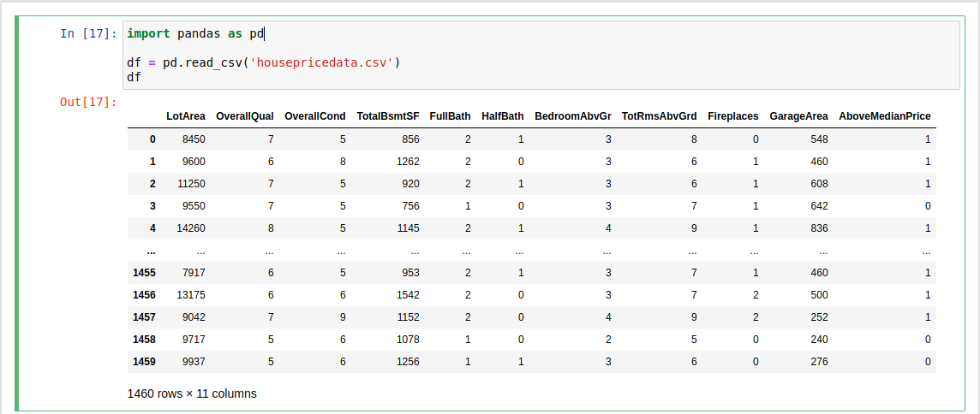

dataset = df.values

dataset

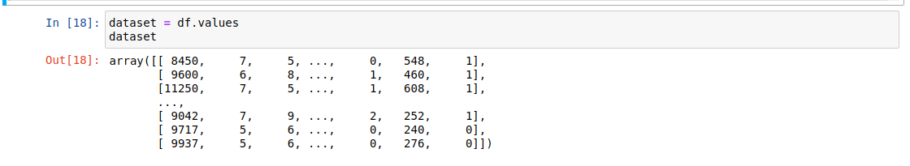X = dataset[:,0:10]

Y = dataset[:,10]

from sklearn import preprocessing

min_max_scaler = preprocessing.MinMaxScaler()

X_scale = min_max_scaler.fit_transform(X)

X_scale

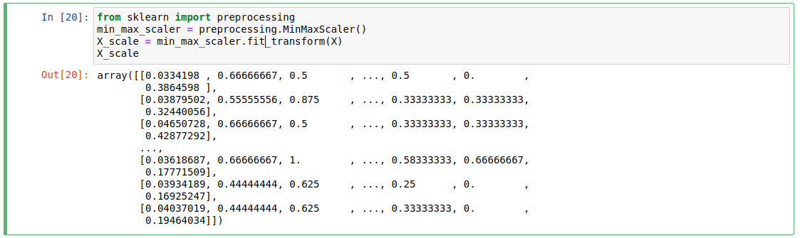from sklearn.model_selection import train_test_split

X_train, X_val_and_test, Y_train, Y_val_and_test = train_test_split(X_scale, Y, test_size=0.3)

X_val, X_test, Y_val, Y_test = train_test_split(X_val_and_test, Y_val_and_test, test_size=0.5)

print(X_train.shape, X_val.shape, X_test.shape, Y_train.shape, Y_val.shape, Y_test.shape)

from keras.models import Sequential

from keras.layers import Dense

model = Sequential([

Dense(32, activation='relu', input_shape=(10,)),

Dense(32, activation='relu'),

Dense(1, activation='sigmoid'),

])

model.compile(optimizer='sgd',

loss='binary_crossentropy',

metrics=['accuracy'])

hist = model.fit(X_train, Y_train,

batch_size=32, epochs=100,

validation_data=(X_val, Y_val))

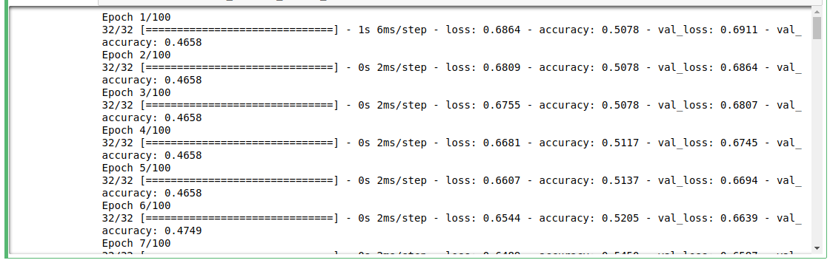

model.evaluate(X_test, Y_test)[1]

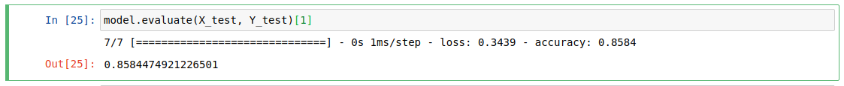import matplotlib.pyplot as plt

plt.plot(hist.history['loss'])

plt.plot(hist.history['val_loss'])

plt.title('Model loss')

plt.ylabel('Loss')

plt.xlabel('Epoch')

plt.legend(['Train', 'Val'], loc='upper right')

plt.show()

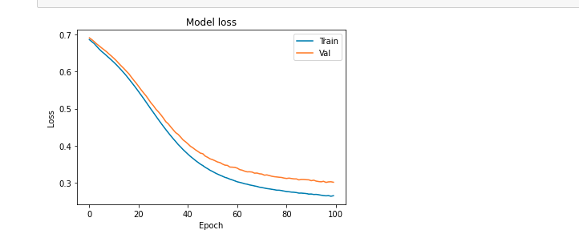

plt.plot(hist.history['accuracy'])

plt.plot(hist.history['val_accuracy'])

plt.title('Model accuracy')

plt.ylabel('Accuracy')

plt.xlabel('Epoch')

plt.legend(['Train', 'Val'], loc='lower right')

plt.show()

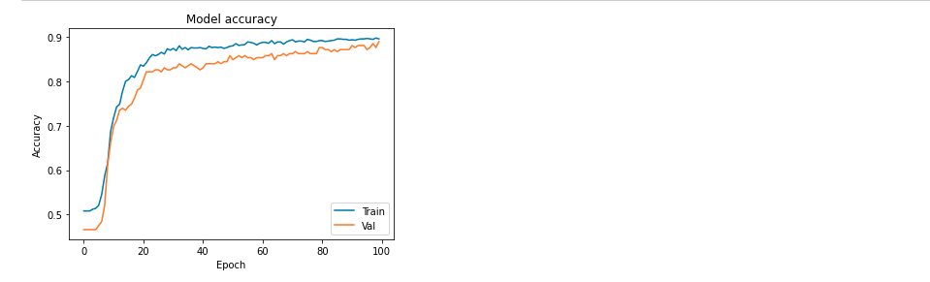

model_2 = Sequential([

Dense(1000, activation='relu', input_shape=(10,)),

Dense(1000, activation='relu'),

Dense(1000, activation='relu'),

Dense(1000, activation='relu'),

Dense(1, activation='sigmoid'),

])

model_2.compile(optimizer='adam',

loss='binary_crossentropy',

metrics=['accuracy'])

hist_2 = model_2.fit(X_train, Y_train,

batch_size=32, epochs=100,

validation_data=(X_val, Y_val))

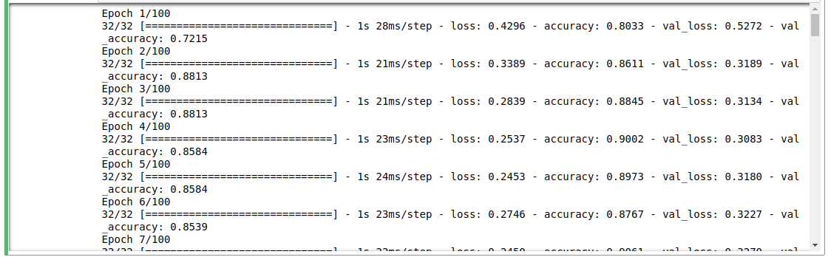

plt.plot(hist_2.history['loss'])

plt.plot(hist_2.history['val_loss'])

plt.title('Model loss')

plt.ylabel('Loss')

plt.xlabel('Epoch')

plt.legend(['Train', 'Val'], loc='upper right')

plt.show()

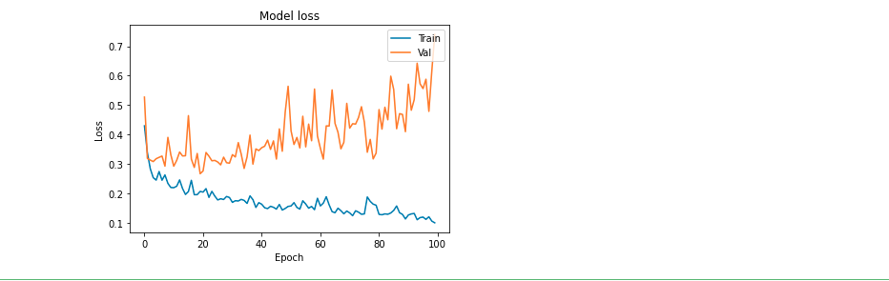

plt.plot(hist_2.history['accuracy'])

plt.plot(hist_2.history['val_accuracy'])

plt.title('Model accuracy')

plt.ylabel('Accuracy')

plt.xlabel('Epoch')

plt.legend(['Train', 'Val'], loc='lower right')

plt.show()

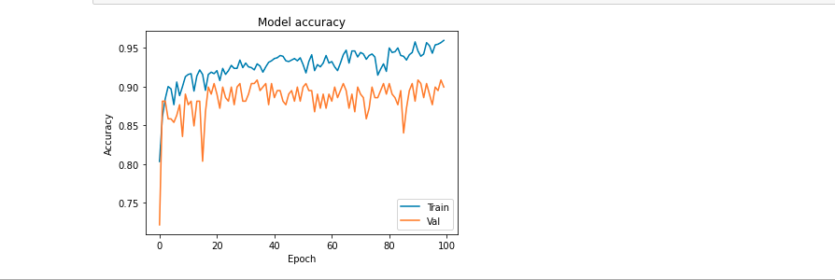

from keras.layers import Dropout

from keras import regularizers

model_3 = Sequential([

Dense(1000, activation='relu', kernel_regularizer=regularizers.l2(0.01), input_shape=(10,)),

Dropout(0.3),

Dense(1000, activation='relu', kernel_regularizer=regularizers.l2(0.01)),

Dropout(0.3),

Dense(1000, activation='relu', kernel_regularizer=regularizers.l2(0.01)),

Dropout(0.3),

Dense(1000, activation='relu', kernel_regularizer=regularizers.l2(0.01)),

Dropout(0.3),

Dense(1, activation='sigmoid', kernel_regularizer=regularizers.l2(0.01)),

])

model_3.compile(optimizer='adam',

loss='binary_crossentropy',

metrics=['accuracy'])

hist_3 = model_3.fit(X_train, Y_train,

batch_size=32, epochs=100,

validation_data=(X_val, Y_val))

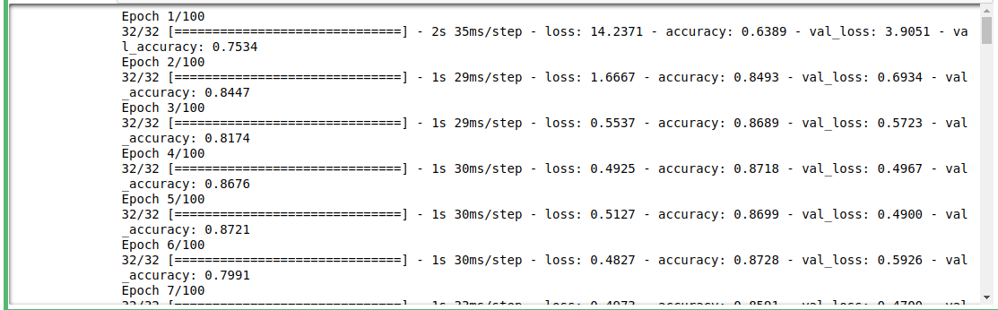

plt.plot(hist_3.history['loss'])

plt.plot(hist_3.history['val_loss'])

plt.title('Model loss')

plt.ylabel('Loss')

plt.xlabel('Epoch')

plt.legend(['Train', 'Val'], loc='upper right')

plt.ylim(top=1.2, bottom=0)

plt.show()

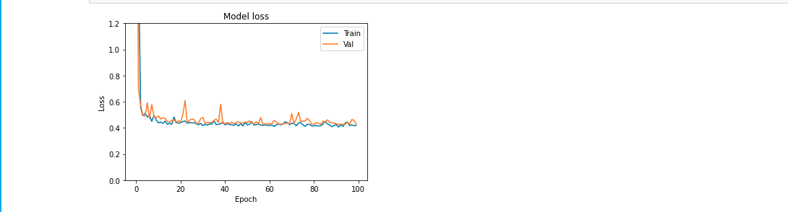

plt.plot(hist_3.history['accuracy'])

plt.plot(hist_3.history['val_accuracy'])

plt.title('Model accuracy')

plt.ylabel('Accuracy')

plt.xlabel('Epoch')

plt.legend(['Train', 'Val'], loc='lower right')

plt.show()

